Heptagrammic Cuploid

Definition
# Source: AI Source: Provided by: [Data Path: Persons Table -> ID Column: 1, Name_En Column: Motasem Essam] -> From: [ChatGPT] on [7/25/2026]
A Heptagrammic Cuploid, also known as a $\{7/2\}$-Cuploid, is a specialized non-orientable polyhedral construction related to star-cupolas.
It is based on a seven-pointed star (heptagram). Its construction uses triangular and square faces arranged around the star-shaped upper boundary. The lower polygonal base is degenerate and is removed, leaving the faces connected directly along the lower boundary.
Like the Pentagrammic Cuploid, the $\{7/2\}$-Cuploid includes a membrane across its star-shaped base because the lateral faces do not cover the entire region.
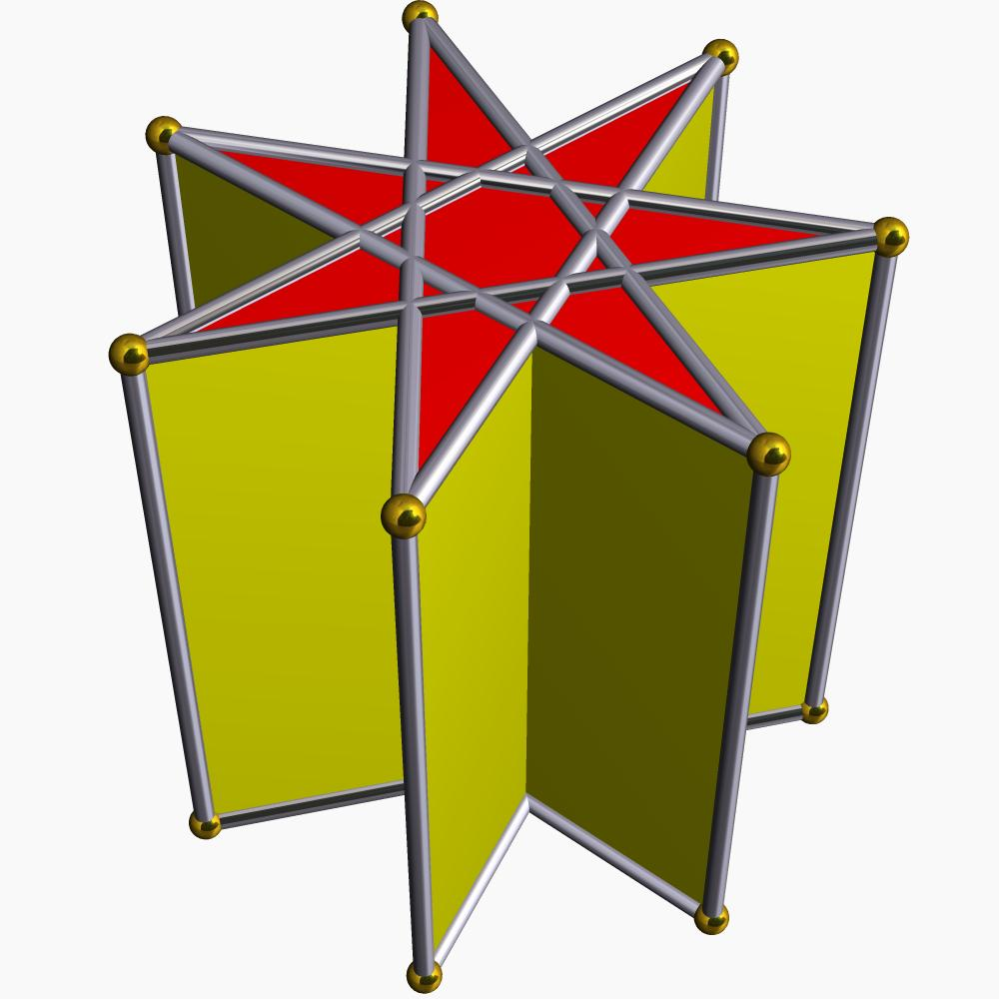

Simple Definition
# Source: AI Source: Provided by: [Data Path: Persons Table -> ID Column: 1, Name_En Column: Motasem Essam] -> From: [ChatGPT] on [7/25/2026]
A Heptagrammic Cuploid is a three-dimensional non-orientable geometric structure built around a seven-pointed star, with triangular and square faces and a removed degenerate lower base.

Geometric Structure
# Source: AI Source: Provided by: [Data Path: Persons Table -> ID Column: 1, Name_En Column: Motasem Essam] -> From: [ChatGPT] on [7/25/2026]
Its star-polygon notation is:
$$\boxed{\{7/2\}}$$
This notation means:
- 7 represents the seven vertices of the star polygon.
- 2 represents the step size used to connect the vertices.
- Each vertex connects to the vertex two positions ahead.
- The resulting boundary forms a seven-pointed star.
- The lower polygonal base is degenerate and is removed.
- A membrane covers the remaining star-shaped region.
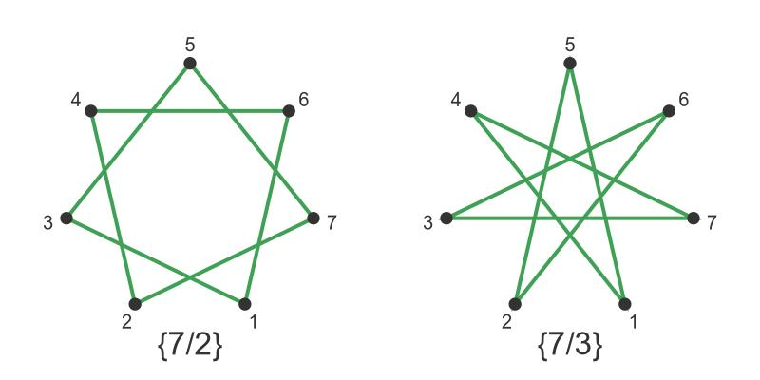

Face Structure
# Source: AI Source: Provided by: [Data Path: Persons Table -> ID Column: 1, Name_En Column: Motasem Essam] -> From: [ChatGPT] on [7/25/2026]
In the standard Heptagrammic Cuploid construction, the faces are:
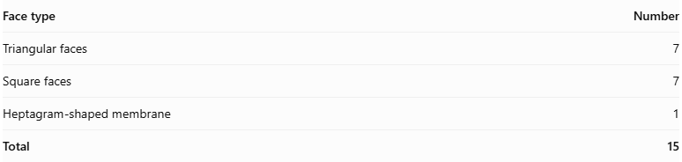
Face type | Number
Triangular faces | 7
Square faces | 7
Heptagram-shaped membrane | 1
Total | 15
The seven triangular and seven square faces form the lateral structure. The membrane covers the remaining star-shaped region.

Edge Structure
# Source: AI Source: Provided by: [Data Path: Persons Table -> ID Column: 1, Name_En Column: Motasem Essam] -> From: [ChatGPT] on [7/25/2026]
For the standard realization:
- 28 edges.
- Edges connect the triangular and square faces.
- The faces follow the crossed arrangement of the heptagram.
- The lower polygonal base is absent.

Vertex Structure
# Source: AI Source: Provided by: [Data Path: Persons Table -> ID Column: 1, Name_En Column: Motasem Essam] -> From: [ChatGPT] on [7/25/2026]
The standard realization has 14 vertices.
- Seven vertices form the upper heptagram arrangement.
- Seven additional vertices belong to the connected lower portions of the structure.
- The vertices connect the triangular and square faces.

Mathematical Properties
# Source: AI Source: Provided by: [Data Path: Persons Table -> ID Column: 1, Name_En Column: Motasem Essam] -> From: [ChatGPT] on [7/25/2026]
Geometric data
15
Faces
28
Edges
14
Vertices
Non-orientable
Surface property
Euler characteristic:
$$V-E+F=14-28+15=1$$
The Euler characteristic of 1 is consistent with the non-orientable projective-plane topology of cuploids.

The Heptagram Membrane
# Source: AI Source: Provided by: [Data Path: Persons Table -> ID Column: 1, Name_En Column: Motasem Essam] -> From: [ChatGPT] on [7/25/2026]
One distinctive feature of the Heptagrammic Cuploid is its heptagram-shaped membrane.
- The seven triangular and seven square faces do not cover the entire star-shaped region.
- A central region remains uncovered by the lateral faces.
- A membrane fills this region.
- The membrane is part of the polyhedral surface, not an ordinary solid-filled base.
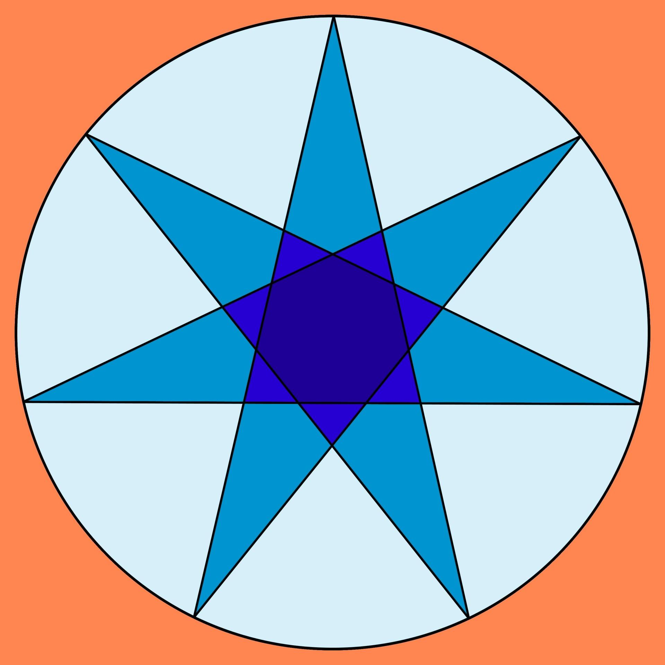

Symmetry
# Source: AI Source: Provided by: [Data Path: Persons Table -> ID Column: 1, Name_En Column: Motasem Essam] -> From: [ChatGPT] on [7/25/2026]
The regular $\{7/2\}$ star arrangement has dihedral symmetry $D_{7}$, including:
- Sevenfold rotational symmetry.
- Seven reflection symmetries.
The complete solid inherits the corresponding symmetry when constructed in its regular symmetric arrangement.

Relationship to Other Solids
# Source: AI Source: Provided by: [Data Path: Persons Table -> ID Column: 1, Name_En Column: Motasem Essam] -> From: [ChatGPT] on [7/25/2026]
The Heptagrammic Cuploid belongs to the star-cuploid family.
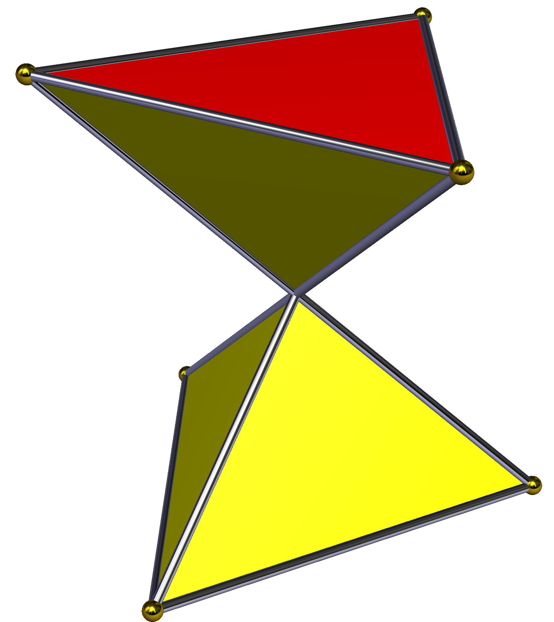
Crossed Triangular Cuploid
{3/2}
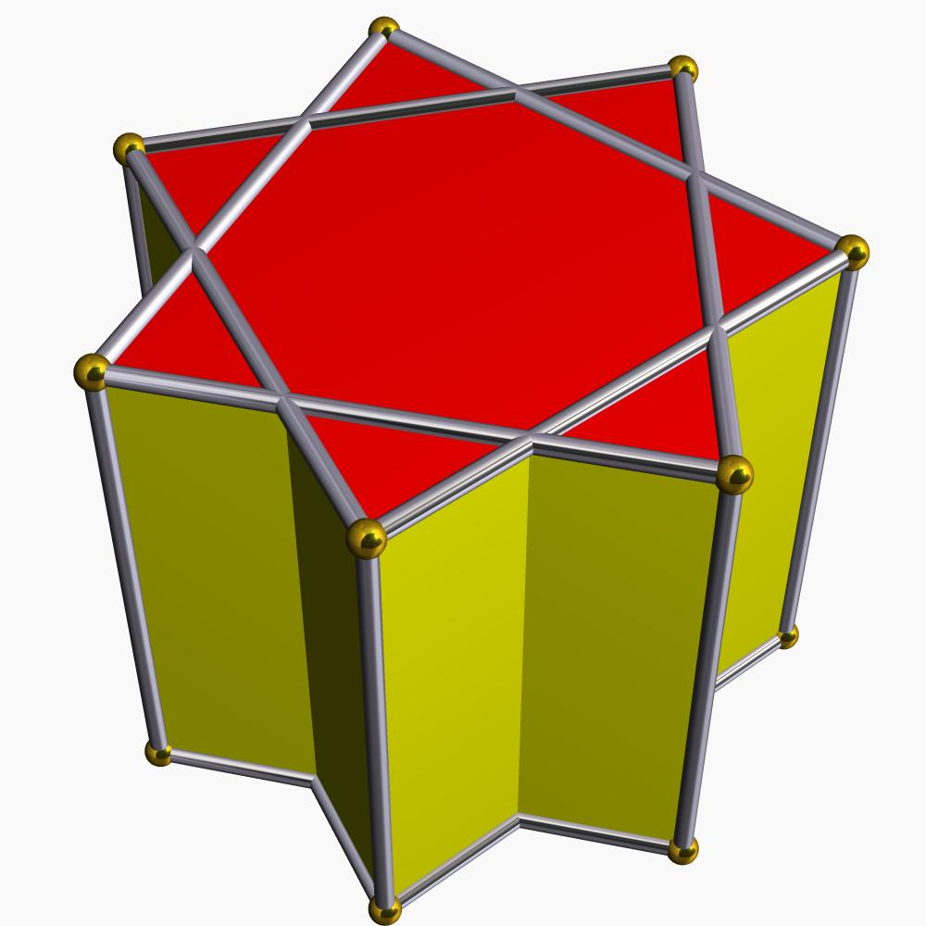
Pentagrammic Cuploid
{5/2}
Heptagrammic Cuploid
{7/2}
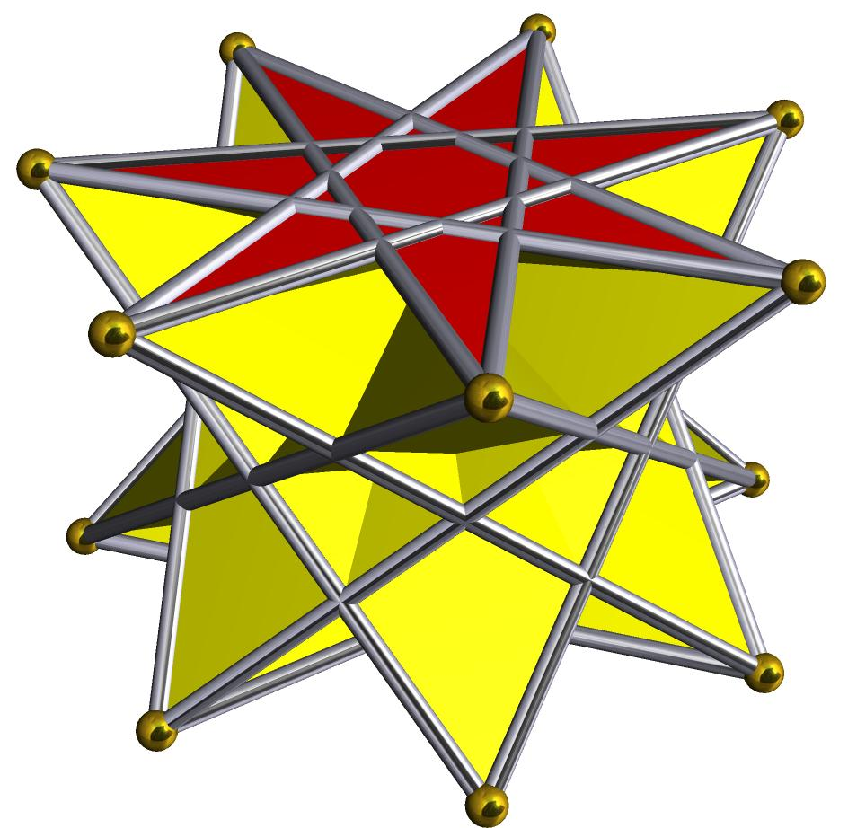
Crossed Heptagrammic Cuploid
{7/4}
Important distinction: The Heptagrammic Cuploid $\{7/2\}$ is different from the Crossed Heptagrammic Cuploid $\{7/4\}$. They use different star-polygon connection patterns.

Construction of a Heptagrammic Cuploid

Geometric Instruments Used
# Source: AI Source: Provided by: [Data Path: Persons Table -> ID Column: 1, Name_En Column: Motasem Essam] -> From: [ChatGPT] on [7/25/2026]
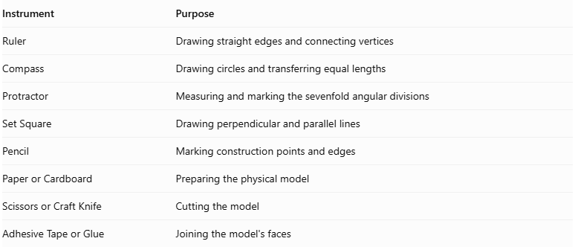
Instrument | Purpose
Ruler | Drawing straight edges and connecting vertices
Compass | Drawing circles and transferring equal lengths
Protractor | Measuring and marking the sevenfold angular divisions
Set Square | Drawing perpendicular and parallel lines
Pencil | Marking construction points and edges
Paper or Cardboard | Preparing the physical model
Scissors or Craft Knife | Cutting the model
Adhesive Tape or Glue | Joining the model's faces
Construction note: A regular heptagon cannot be constructed exactly using only an unmarked straightedge and compass. A protractor or another suitable angle-measuring instrument can be used for a measured construction.

Instrument-Based Construction Procedures

Constructing the Heptagram
# Source: AI Source: Provided by: [Data Path: Persons Table -> ID Column: 1, Name_En Column: Motasem Essam] -> From: [ChatGPT] on [7/25/2026]
- Draw a circle using a compass.
- Mark seven approximately equally spaced points around its circumference using a protractor.
- Label the points $A,B,C,D,E,F,G$ in circular order.
- Connect every second vertex to form the heptagram $\{7/2\}$.
- Check that the star has seven outer vertices and a consistent sevenfold arrangement.
The angular spacing between consecutive vertices is:
$$\frac{{360}^{°}}{7}≈{51.4286}^{°}$$
The star connection advances by two vertex positions at a time.

Constructing the Seven Square Faces
# Source: AI Source: Provided by: [Data Path: Persons Table -> ID Column: 1, Name_En Column: Motasem Essam] -> From: [ChatGPT] on [7/25/2026]
- Identify the seven edge regions associated with the heptagrammic arrangement.
- Construct seven square faces with matching edge lengths.
- Arrange the squares around the star structure according to the cuploid's face-adjacency pattern.
- Check that their edges align with the intended triangular and star-polygon boundaries.

Constructing the Seven Triangular Faces
# Source: AI Source: Provided by: [Data Path: Persons Table -> ID Column: 1, Name_En Column: Motasem Essam] -> From: [ChatGPT] on [7/25/2026]
- Construct seven triangular faces.
- Match their edges to the corresponding square and heptagrammic boundary edges.
- Arrange the triangles between the appropriate square-face connections.
- Check that the triangular faces follow the sevenfold arrangement.

Connecting the Faces
# Source: AI Source: Provided by: [Data Path: Persons Table -> ID Column: 1, Name_En Column: Motasem Essam] -> From: [ChatGPT] on [7/25/2026]
- Connect the square and triangular faces according to the Heptagrammic Cuploid's topology.
- Remove the degenerate $\{14/2\}$ base arrangement rather than constructing it as an ordinary polygonal face.
- Join the adjoining lateral faces directly along their corresponding edges.
- Preserve the heptagrammic boundary and its central membrane region.
- Verify that the resulting structure matches the intended non-orientable arrangement.

Completing the Solid Drawing
# Source: AI Source: Provided by: [Data Path: Persons Table -> ID Column: 1, Name_En Column: Motasem Essam] -> From: [ChatGPT] on [7/25/2026]
- Draw the visible edges using continuous lines.
- Draw hidden edges using dashed lines where appropriate.
- Distinguish the heptagrammic face from the triangular and square faces.
- Check the sevenfold symmetry.
- Inspect the complete face connections for missing or incorrectly joined edges.

Key Points
# Source: AI Source: Provided by: [Data Path: Persons Table -> ID Column: 1, Name_En Column: Motasem Essam] -> From: [ChatGPT] on [7/25/2026]
- The Heptagrammic Cuploid is represented by $\{7/2\}$.
- It is based on a seven-pointed star.
- It has seven triangular faces and seven square faces.
- It includes a heptagram-shaped membrane.
- Its standard realization has 15 faces, 28 edges, and 14 vertices.
- It is non-orientable.
- It has sevenfold rotational symmetry.
- It is different from the $\{7/4\}$ Crossed Heptagrammic Cuploid.

Conclusion
# Source: AI Source: Provided by: [Data Path: Persons Table -> ID Column: 1, Name_En Column: Motasem Essam] -> From: [ChatGPT] on [7/25/2026]
The Heptagrammic Cuploid is a specialized non-orientable polyhedral construction based on a seven-pointed star. Its combination of triangular faces, square faces, and a central heptagram-shaped membrane makes it an interesting example of advanced solid geometry and polyhedral topology.

